**Easy Premature Baby Cardigan**

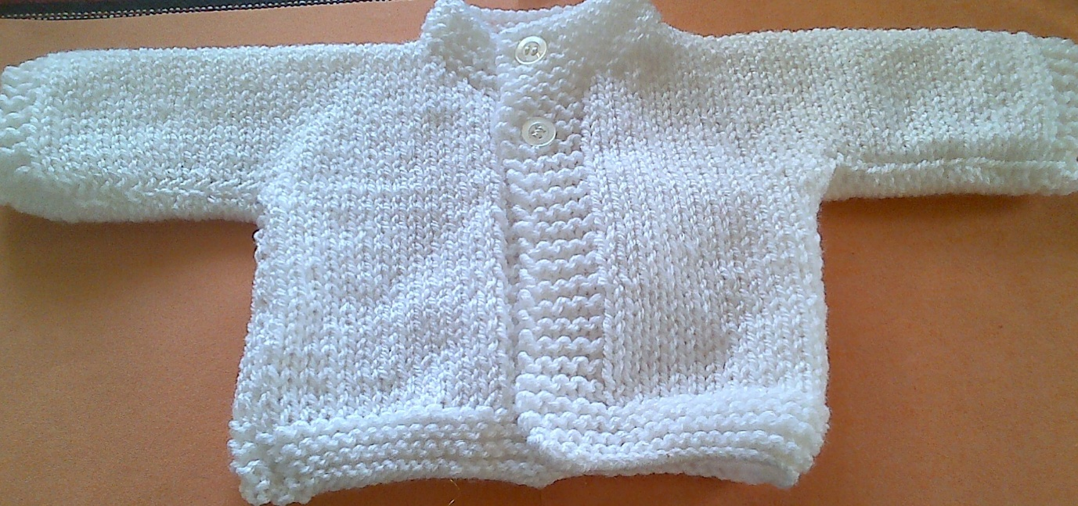

Baby double knitting wool in pastel colours

3.25mm needles

4mm needles

RIGHT FRONT

Cast on 21 stitches with size 3.25mm needles

Garter stitch for 8 rows

Change to size 4mm needles

9th row Knit

10th row Purl to last 5 stitches, knit the last 5 stitches

Work 21 more rows as 9th & 10th

Cast on 18 stitches for the sleeve

Knit 3 stitches, purl to the last 5 stitches, knit 5

Next row: Knit

Work 9 rows as above

Shape neck:

Next row: Knit 5 stitches then slip these stitches onto a safety pin, knit 2 together then knit to end

Decrease 1 stitch at neck edge on next 4 rows and on the next alternate row (28 stitches)

Slip these remaining stitches onto a stitch holder.

LEFT FRONT

Cast on 21 stitches with size 3.25mm needles

Garter stitch for 8 rows

Change to size 4mm needles

9th row: Knit

10th row: Knit 5, purl to end.

Work 21 more rows as 9th & 10th

Cast on 18 stitches for the sleeve

Row 1 Knit

Row 2 Knit 5, purl to the last 3 stitches, knit 3

Row 3 Knit

Row 4 Knit 5, purl to the last 3 stitches, knit 3

Row 5 Buttonhole row – knit to the last 3 stitches, wool forward, knit 2 together tbl, knit 1

Row 6 Knit 5, purl to the last 3 stitches, knit 3

Row 7 Knit

Row 8 Knit 5, purl to the last 3 stitches, knit 3

Repeat rows 7 and 8 twice more.

Shape neck:

Row 1 Knit to the last 8 stitches, knit 2 together, slip remaining 6 stitches on to a safety pin.

Row 2 Purl 2 together, purl to last 3 stitches, knit 3

Row 3 Knit to the last 2 stitches, knit 2 together

Row 4 Purl 2 together, purl to last 3 stitches, knit 3

Row 5 Knit

Row 6 as Row 4 (28 stitches)

BACK

Knit across the stitches on the left front

Cast on 15 stitches

Knit across the right front (71 stitches)

Work 19 rows in stocking stitch, keeping 3stitch border at each end.

Cast off 18 stitches at the beginning of the next 2 rows

Work 19 rows in stocking stitch

Change to size 3.25mm needles, knit 8 rows in garter stitch.

Cast off.

NECK

Using size 4mm needles, knit 6 stitches from the safety pin, 8 stitches up shaping, 15 stitches from the back, 8 stitches from the shaping and 6 stitches from the safety pin.

Knit 6 rows in garter stitch.

Buttonhole row: Knit to last 3 stitches, knit 2 together tbl, knit 1

Next row: Knit

Cast off.

To make up, stitch up side seams and along sleeve seams.

Add 2 buttons to correspond with buttonholes.